**Experimental setup for RFPP calculation**

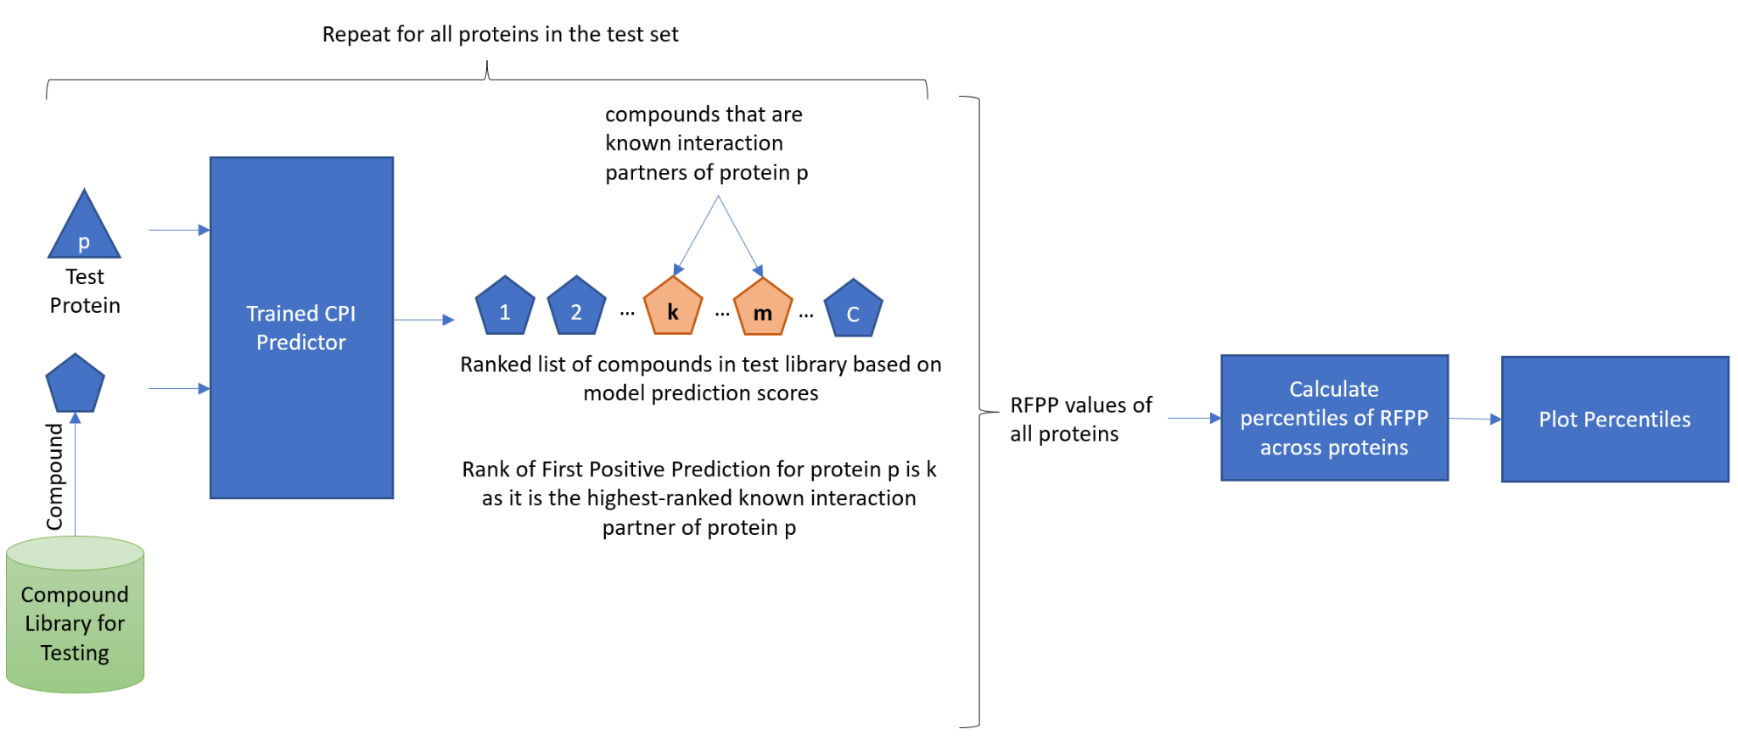

Figure 2 Steps in RFPP calculation